

Local AI Configuration

SHeen, AleN T(Student)

Purpose:
The purpose of this lab is to build and configure a fully local AI system capable of providing private, high-performance generative AI services to users on the same network. By running the AI model on dedicated on-premises hardware, this setup improves security, reduces reliance on external cloud services, and allows faster, more reliable access for internal use. This lab demonstrates how organizations can centralize AI resources, optimize hardware usage, and support multiple departments with tailored AI capabilities.
Definitions:
Generative AI (Gen AI):
A type of artificial intelligence, such as ChatGPT, that produces new content by predicting the most likely output based on user input.
Token:
A small unit of text—often a word fragment or piece of punctuation—that serves as one of the core elements of language in AI models.
Embedding:
A process that represents each token as a series of numerical values across different dimensions, allowing the AI to interpret meaning and context.
Vector:
A mathematical concept describing both magnitude and direction, often used to represent data points in multiple dimensions.
Compute:
A measure of the computational resources needed to complete a task, defined as the product of processing power and time.
Open Source:
Software that is freely available for anyone to use, modify, or distribute, typically with public access to its source code.
Matrix:
A rectangular grid of numbers organized into rows and columns, commonly used to represent data or perform calculations.
Tensor:
An extension of a matrix that can exist in more than two dimensions, allowing for the representation of complex, multi-dimensional data (such as time, location, and other variables).

FLOP (Floating-Point Operation):

A single calculation—such as addition, subtraction, multiplication, or division—involving numbers with decimal points.

LLM (Large Language Model):

A type of generative AI system trained on vast amounts of text data to generate and understand natural language.

Attention:

So the thing that makes modern language models work well is that they have a way to constantly change how each word or piece of text is connected to the others around it. This helps the model get a sense of what is being talked about. The model is always adjusting how each token, like a word or a phrase relates to the tokens in a sequence of text. This really helps the model understand the context of the conversation. The model is always trying to improve its understanding of how each token's connected to the others.

Parameter:

A numerical value (typically between –1 and 1) that stores information learned by the model during training.

MatMul (Matrix Multiplication):

When we talk about Artificial Intelligence, one of the math things it does is something called matrix multiplication. This is where the Artificial Intelligence system takes two grids of numbers which we call matrices and it combines them. It does this by multiplying and adding the numbers, in these grids times. The Artificial Intelligence system uses this grid of numbers, which is the result of the matrix multiplication to do other things. Matrix multiplication is a part of how Artificial Intelligence works.

GPU (Graphics Processing Unit):

This thing called a processor was first used to make pictures and graphics look good. Now it is used a lot for Artificial Intelligence because the specialized processor can do small jobs at the same time very efficiently. The specialized processor is really good, at handling lots of tasks all at once.

AAA (Authentication, Authorization, Accounting):

A framework used in networking to manage and secure user access by verifying identity, granting permissions, and tracking usage.

Background Information:

AI Basics:

In todays world intelligence that can create things is really well known. These systems can predict what will happen and make text, pictures or other things that people can see. When people say they are using intelligence they are usually talking about these systems. There are some ones like ChatGPT, Gemini, Microsoft Copilot, Grok and Metas Llama. Metas Llama is really important because it is source, which means a lot of people can use it and help make it better. Metas Llama is also supported by people and it works well on cheaper computers, which is not true for many other systems that are not open source. Artificial intelligence, like Metas Llama is changing the way we do things. For this lab I picked Llama 3.1 8B. I chose Llama 3.1 8B because it works well.. That is not the only reason I chose Llama 3.1 8B. I also chose Llama 3.1 8B because its license is open-source. This means I have control, over Llama 3.1 8B. I can make changes to Llama 3.1 8B. This is something that models with closed-source licenses do not let me do with them.

So basically generative models work with something called prediction. They do not understand text like we do. These models break down text into parts, which are usually smaller than words and they call these parts tokens.

Each token is then shown as a vector with a lot of dimensions. For instance Llama 3.1 8B uses vectors that have 4096 dimensions for every token.

Each dimension of these vectors is connected to some part of the meaning or context or how the tokens are related to each other. Generative models, like Llama 3.1 8B use token prediction to make sense of the tokens. Token prediction is a part of how these models work with text. The model learns what each dimension means by using the information it gets from its training data. It does this by changing a number of things to make its predictions more accurate. The model looks at the training data. Figures out how everything is connected, which helps it make better guesses. This is how the model gets better at predicting things even if people do not really understand what each dimension represents.

When the model generates text it looks at the words that came before and tries to figure out what word should come next. The model updates what it thinks it knows and then makes a guess about the word. This is not like how a person thinks. The model does not think like a human. It uses a lot of math to make these guesses. It does a lot of multiplying and adding. For one word the model does a huge number of these math problems. The model does trillions of these operations for a word, in a small 8B model. The model is doing a lot of work to generate text like guessing the word by using math and the words that came before.

The math involved in Artificial Intelligence is really big. This is why Artificial Intelligence needs hardware to work properly. If Artificial Intelligence did not have hardware it would take a very long time to generate just a few words of text. Each math problem that Artificial Intelligence has to solve is not that hard, on its own. Artificial Intelligence has to solve so many of them and that is what makes Artificial Intelligence need a lot of computer power.

GPUs:

The thing that makes modern Artificial Intelligence work is the Graphics Processing Unit or GPU for short. The company NVIDIA made the GPU back in 1999 to make video games look better. They wanted to make it possible for computers to quickly move lots of pictures and objects around on the screen. This needs a kind of math that can handle lots of numbers at the time, which is also what Artificial Intelligence needs to work. It is of funny that Graphics Processing Units turned out to be so good for Artificial Intelligence but once people figured this out the field of Artificial Intelligence started to grow really fast. The Graphics Processing Unit is really important, for Artificial Intelligence.

These new graphics cards have lots of cores that can do things at the same time. This makes them really fast for tasks that need networks.

The companies that make these graphics cards kept making them better for intelligence work. They added special parts called Tensor Cores.

They also made the memory work faster. Added special systems to help with math problems that involve lots of numbers like matrix multiplication. Graphics cards are really good, at this kind of math because of these systems and the Tensor Cores.

The NVIDIA Blackwell B200 is a powerful computer part. It can do a lot of things quickly. In fact it can do 20 quadrillion things per second. This is much faster than a person can think. The NVIDIA Blackwell B200 and other similar computer parts can make answers from intelligence very quickly.

These computer parts are very expensive. Most people do not need them to do their work. For instance the RTX A4000 is used in this laboratory. It can do around 153 trillion things, per second. The NVIDIA Blackwell B200 and the RTX A4000 are both computer parts that are used for tasks. The computer is not as powerful, as Blackwell. It can definitely run an 8B model in real time. This means that when you use the computer you will not notice any delay. The computer can handle the 8B model easily.

The main thing to know is that you do not need the expensive computer parts for generative AI to be useful. Generative AI models like Llama 3.1 8B show that if you design things well and use the methods smaller generative AI models can give you good results on less expensive computers. This means that generative AI is something that businesses and individuals can use even if they want to be, in charge of their generative AI models and do not want to rely on big companies that provide computer services over the internet.

Purpose of dedicated AI computers:

GPUs make it possible to have intelligence on our own computers.. It does not make sense to put a GPU in every single employees computer. This is because it is very expensive and not a good use of resources. Most employees do not use intelligence all the time. So the GPU is just sitting there doing nothing for a part of the day. This means we are wasting power and wasting the hardware itself. It is also not a way to spend our money because we are not getting a good return, on our investment. GPUs and artificial intelligence are important. We need to think of a better way to use them.

Using an approach is to put all the artificial intelligence computing in one place, like dedicated servers. This way employees only connect to the intelligence server when they really need to use it. The server does all the work. The employees get the results over the network.

When a company does this they can figure out how much the artificial intelligence is used on average and, at its busiest. Then they can buy the right number of graphics processing units or GPUs to handle that amount of work. For example of buying one hundred graphics processing units for one hundred employees a company might only need three to ten graphics processing units depending on how often the employees actually use the artificial intelligence tools.

Centralization has another thing going for it which is flexibility. When all the different departments use artificial intelligence tools these tools can be given out from one main system. For instance the Human Resources department may need an artificial intelligence model that is good at writing clean and professional emails. The Information Technology department on the hand might need a more complex model that can fix problems in system logs or understand computer code. The Marketing department might need an intelligence model that is good, at creative writing or planning marketing campaigns. This way each department gets the intelligence tools they need from one central place.

A centralized server is really good because it can have different models on it. These models can be big or small. They can do different things. The server can switch between these models depending on what task it needs to do. This is very useful because if every employee had their special computer part called a GPU it would be very expensive or just not possible. So this way is better because it helps the computer work well and it does not waste hardware. The centralized server and the models, on it are very flexible. The centralized server and its models can do things better. They can help reduce waste of computer parts.

When companies start using Artificial Intelligence tools they need to have a centralized approach. This approach is important because it makes it easy to do updates. It also helps companies to grow and manage Artificial Intelligence tools better. Additionally a centralized approach helps companies to keep their security and data handling practices in order. This means companies can manage their Artificial Intelligence tools and keep their information safe in one place.

Why not cloud-based hardware:

Cloud computing has a lot of things to offer. With cloud services companies can use powerful computers without having to buy them. This means companies can get a lot power when they need it like when they are really busy. Cloud computing centers are over the world so companies do not have to worry about their computers stopping work or getting damaged in a disaster. Cloud computing is very reliable. That is a big benefit, for companies that use cloud services and cloud computing.

So we know that cloud AI has some things going for it.. That makes you wonder why would anyone pick local hardware instead? Well there are some reasons why cloud AI is not always the best option. Cloud AI is not the answer every time. That is because local hardware has its own advantages that cloud AI does not have.

One big problem is security. Places like hospitals and banks and also the military have to be very careful with information. They are not allowed to send things over the internet that everyone can use. Even if they use a code to protect it the companies that provide cloud services are still other people and the rules say they cannot send sensitive information to them. On the hand security is better when companies use their own computers because everything stays inside the companys own network and the security of the companys own data and the security of the companys own information is better protected because the companys own security is in charge. The security of hardware is what keeps the companys information safe and the security of the companys data is not, at risk because it is all kept on local hardware.

Latency is a problem. When you use artificial intelligence the information has to go from your computer to the cloud server and then come back. This takes time. That is why cloud artificial intelligence is not good for things that need to happen right away like customer support chat systems or tools that help fix problems inside a company. Some cloud companies have internet options that can make this process faster but these options are usually too expensive for a lot of companies especially when you think about how much it will cost over a long time. Cloud artificial intelligence is still not fast enough because of latency issues, with artificial intelligence.

The cost is also something that people think about a lot. Cloud AI is good for companies that do not use it all the time. For example a company that sometimes needs to use a big model might find that using cloud services is cheap.. If a company uses Cloud AI all the time during the workday then the cost of using the cloud often becomes more expensive than buying their own hardware. If a company uses GPUs more than 40 percent of the time then buying Cloud AI hardware is usually cheaper, within a year because Cloud AI is used a lot. Cloud AI costs can add up if Cloud AI is used every day.

Data ownership is something that people do not think about. A lot of companies that offer cloud AI services say they can use the information that customers give them to train their systems. So if a company sends code or secret emails to a cloud service the service can use that information to make its AI systems better. Then when the service makes those systems available to everyone other companies might get some of that information without even realizing it. This is a problem, for companies that depend on keeping their secrets safe. Data ownership is a deal because companies do not want their private information to get out. When companies use cloud AI services they need to think about data ownership and how it can affect them.

Cloud migration is really not that easy. When you use artificial intelligence you usually have to connect other systems to the cloud providers infrastructure. This can cause a lot of problems make things more complicated and create things that can go wrong. For a lot of companies dealing with all the work is not worth the small advantages that cloud migration brings. Cloud migration is something that a lot of businesses think about carefully before they decide to do it.

So what is a balanced approach? It is like a mix of two things. We use the cloud for things that're not always the same or that we only need for a short time. This is because the cloud is good for things that need to be flexible. On the hand things that we do all the time and that are always the same we do on our own computers. This way we can save money in the run and we have complete control, over our own data. A balanced approach is a system that combines these two things.

Networking Solutions:

Centralizing Artificial Intelligence introduces networking challenges that must be addressed for the Artificial Intelligence system to work effectively. When we centralize Artificial Intelligence we have to deal with some issues that can affect how the Artificial Intelligence system works. These Artificial Intelligence networking challenges need to be fixed so that the Artificial Intelligence system can do its job properly.

One big problem is getting requests to the model. Different parts of the company and different jobs need things set up in ways. For instance when the Human Resources department asks to reword an email it needs to be handled than when the Information Technology department asks to figure out what a system log means. The network has to look at each request decide which model is best, for it and send it to the place. The network has to do this for every request whether it is an HR request or an IT request to make sure the right model handles it.

Load balancing is another problem that companies have to deal with. When a company uses GPUs or several AI machines they need to make sure that the work is spread out evenly. If they do not do this one machine might get much work and another machine will just sit there doing nothing. This is especially hard with GPUs because they are resources that cannot be easily broken down into smaller parts. GPUs are different from CPUs, which can be divided into pieces. For example if someone needs to use a GPU for a task they cannot use half of one GPU and half of another. Good load balancing is important because it makes sure that the machines are always available and that the hardware is being used in the way possible. Load balancing is crucial for companies that use GPUs or AI machines as it helps to get the most out of the hardware and prevent any one machine from becoming overwhelmed. Effective load balancing helps to ensure that all the GPUs and AI machines are being used efficiently which is important, for companies that rely on these machines to get work done.

Security is really important. We need to make sure that Artificial Intelligence systems have user authentication, which means checking who the user is and permissions, which means deciding what they can do and access controls, which means deciding what they can see. Some Artificial Intelligence models may have information or they may have been trained on data that only certain people in the company should be able to see.

We need to use something called AAA, which stands for authentication, authorization and accounting to make sure that only the right people can access Artificial Intelligence models or datasets. This is very important for systems that have secret information that only certain people should know about. Artificial Intelligence systems, with this kind of information need to be very secure.

These networking challenges can be fixed,. You need to plan and set things up carefully. When you use cloud APIs they make things easier by hiding a lot of the stuff behind the interface that the provider gives you.. When you do things locally you have complete control over everything, which is nice but it also means you need to know a lot more about the technical side of things and that can be hard. Networking challenges like these are really, about getting everything to work together smoothly and local deployments are where you need to have an understanding of the technical details to make that happen.

Docker:

To manage and deploy Artificial Intelligence systems efficiently people use containerization tools like Docker. An Artificial Intelligence system is made up of things and Docker helps put all these things together in one place. This way the Artificial Intelligence system works the same on any machine. The good thing about Docker is that it makes it easy to add instances of an Artificial Intelligence system when you need to.

You can have instances of an Artificial Intelligence system running at the same time and Docker makes it easy to manage all of them. This is very useful when you need to make your Artificial Intelligence system available, to a lot of people. Artificial Intelligence systems can be. Docker helps make them easier to use.

Docker is mainly made for Linux.. People who use Windows can still run Docker. They do this by using Windows Subsystem, for Linux 2 which is also known as WSL2.

WSL2 is really useful because it lets Windows users make their Linux environments. These environments are very lightweight. They do not need a full virtual machine.

In our lab we installed Ubuntu inside WSL2. Then we used Docker Desktop, which ran containers using the Ubuntu environment that we set up inside WSL2. Docker is what runs these containers.

Running Artificial Intelligence models inside containers is really helpful. It makes it easy to put the models into action. You do not have to worry about the models not working together. Artificial Intelligence models can also run different models or versions at the same time.

Containers are also simple to move from one machine to another. This makes them very useful for testing and making the environment bigger. Artificial Intelligence models, inside containers are a choice.

Ollama:

Ollama is a tool that helps you run artificial intelligence models on your own computer. It makes it easy to get models manage them and use them. Ollama is very easy to use, which is great, for teams who want to try out models without getting bogged down in complicated settings.

Ollama works with Docker so you can use models as part of a bigger system. It can handle kinds of models and you can run them on your own computer with very little setup. Ollama is a choice because it is easy to use and it supports a wide range of models including the ones you want to run on your local hardware.

Open WebUI:

Open WebUI gives you a way to work with AI models on your own computer. You do not have to use the command line all the time. Open WebUI lets you use a browser to interact with AI models. This makes it a lot easier to test things manage models and see what the AI is saying. Open WebUI is really helpful for people who're not good, with computers and do not know how to use the command line but they still want to use AI models. Open WebUI is really useful because it lets you switch between models customize your prompts keep track of what you have done and work with tools. This makes Open WebUI a great thing to have in any AI system. You can use Open WebUI to do all these things with your AI system and Open WebUI.

Summary:

In this lab I was able to set up a system that can create things on its own using Llama 3.1:8B as the model. This system used an Ollama backend and an Open WebUI interface to connect to it. I put the thing inside a special container called Docker that runs on Ubuntu.. I ran Ubuntu on Windows 11 using something called WSL2. This way I got to use the stuff from Windows and the strong and flexible stuff, from Linux at the same time. I used Llama 3.1:8B. It worked really well with the Ollama backend and Open WebUI interface. I set up a way for users to log in and control who can use the artificial intelligence tools. This means only people I say are okay can use the tools when they are on our network. I found out some important things when I was doing this. I learned that using intelligence on our own machines is different, from using it on the cloud. I also learned that the computer hardware and the size of the intelligence model are connected.. I saw how using containers can make it easier to work with artificial intelligence. The artificial intelligence tools and the containers and the computer hardware all work together to make things simpler. In the end, the system worked as intended and provided a fast, private, and secure AI environment suitable for real-world internal use..

Commands:
AP:
Bridge # route ip – sets bridge group to use IP in that group
Switch:
Interface (interface) - enters interface config mode
Router:
Ip dhcp excluded-address (ip address) (ip address) - excludes addresses from dhcp pools
Configurations:
AP:
service password-encryption
Switch:
end
Router:
end
RADIUS server:
sudo systemctl restart freeradius
Screenshots:
Ollama:
Go to https://ollama.com/download/windows
Click the download for windows button

When the download finishes, open file location


Double click on the file to open the installer
Click Install in the installer
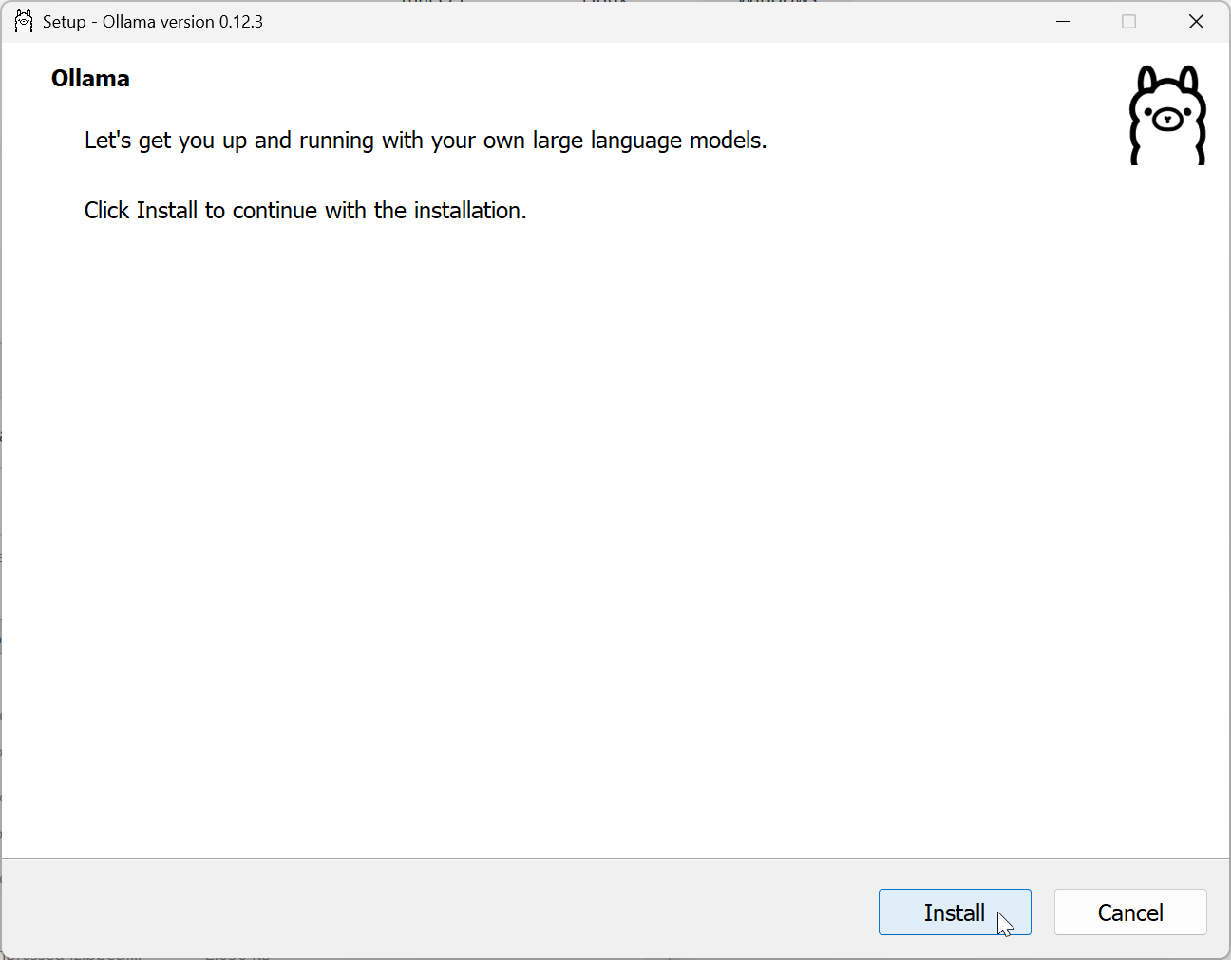
Wait for the installer to finish and close, then open windows PowerShell, then enter the ollama run llama3.1 command
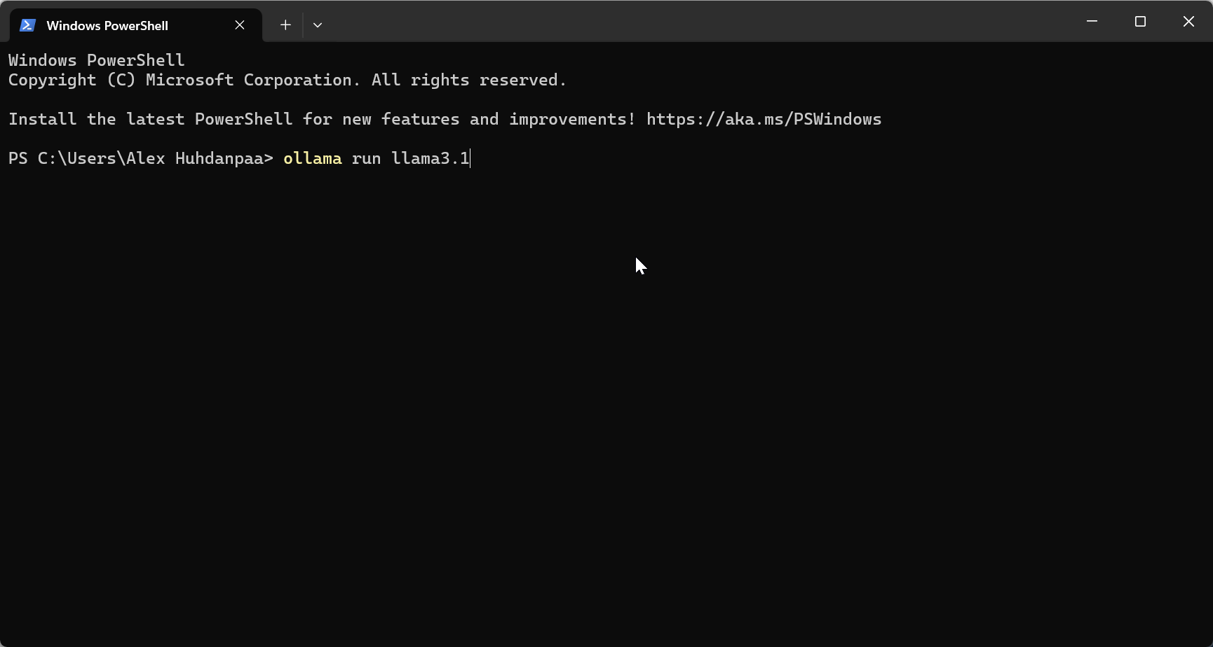
Wait for it to finish, and if successful you should have a text prompt like this
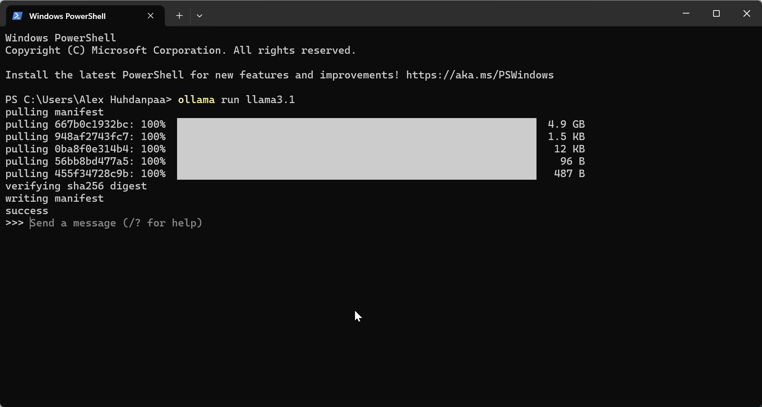
Wsl:
Now install wsl with the wsl --install command
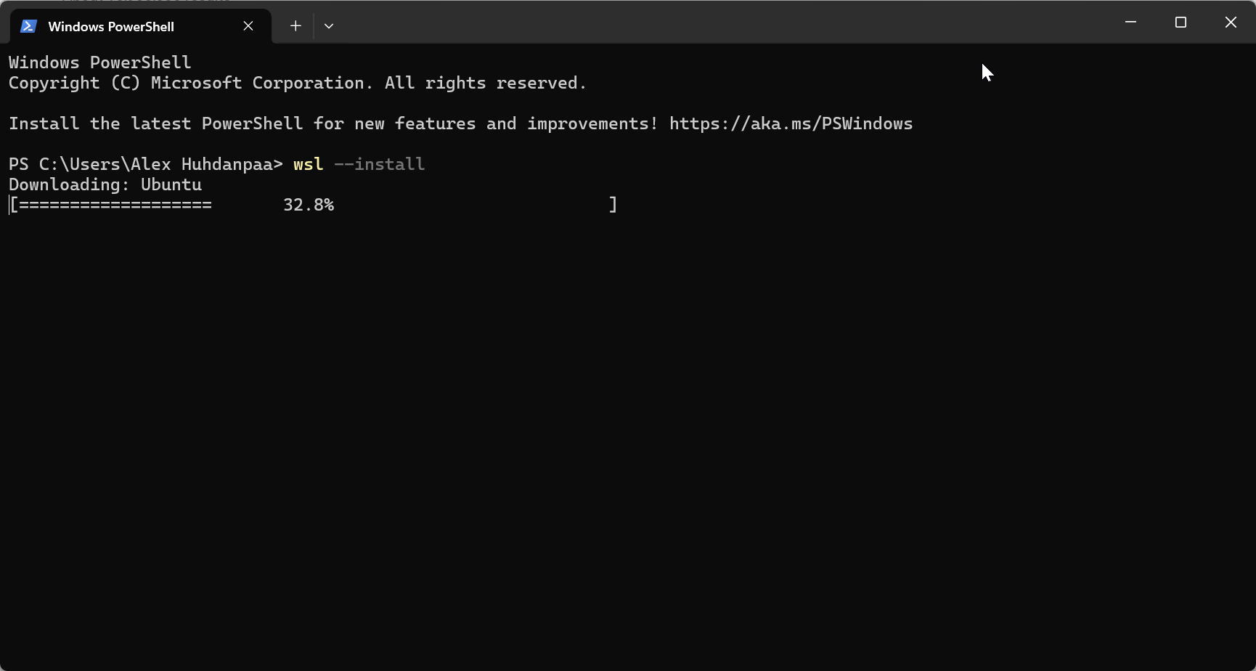
To ensure the latest version enter the wsl --set-default-version 2 command
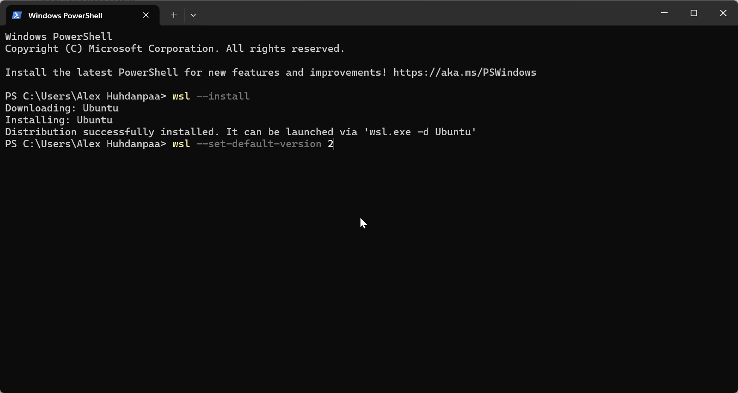
Create your new username and password
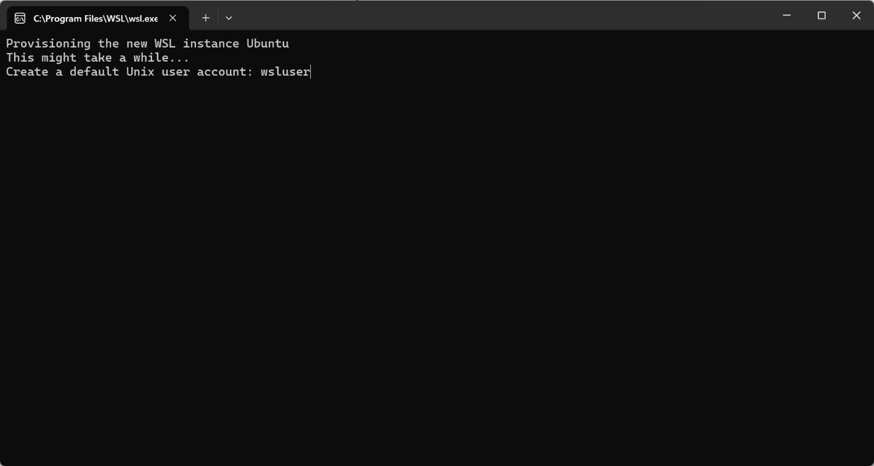
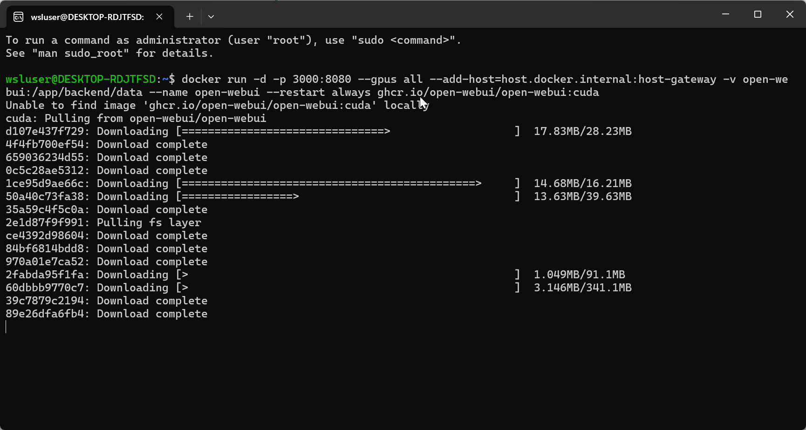
Docker:
Go to https://www.docker.com/products/docker-desktop
Click on download docker desktop then on the version you need, for me this is Windows AMD64
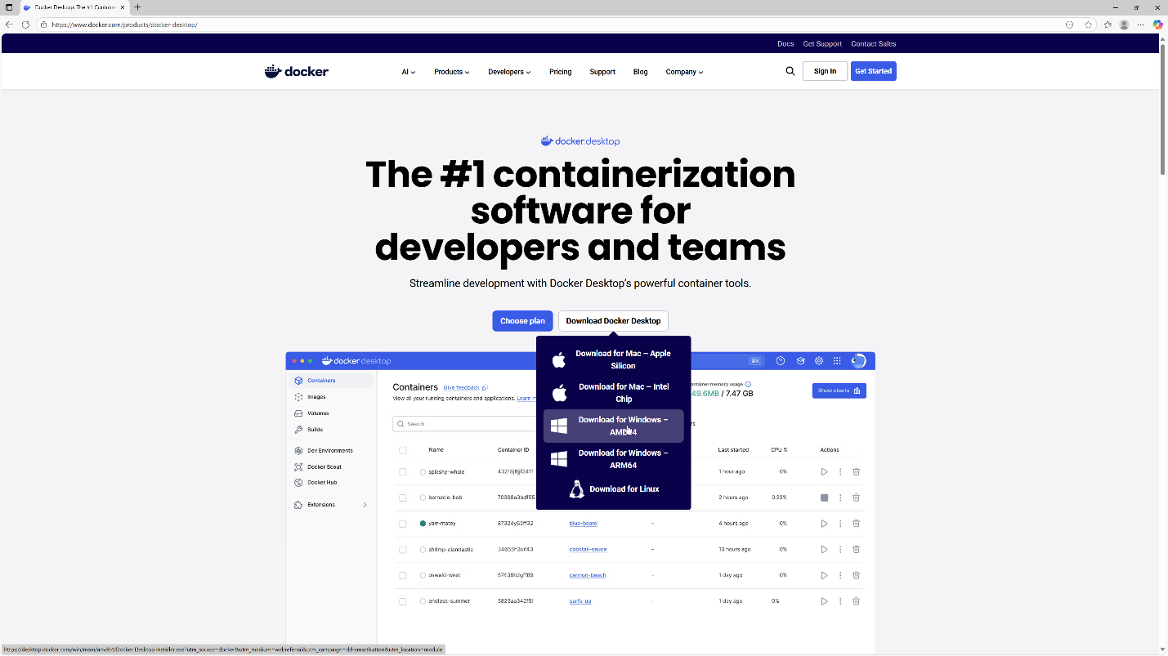
Open File location

Double click on the installer to open it

Open WebUI:
Go to https://github.com/open-webui/open-webui
Once the installer has finished go to the WSL terminal again and enter the following command

Once it has finished open Docker Desktop and navigate to containers and click on the 3000:8080 to open the local web page running the AI model

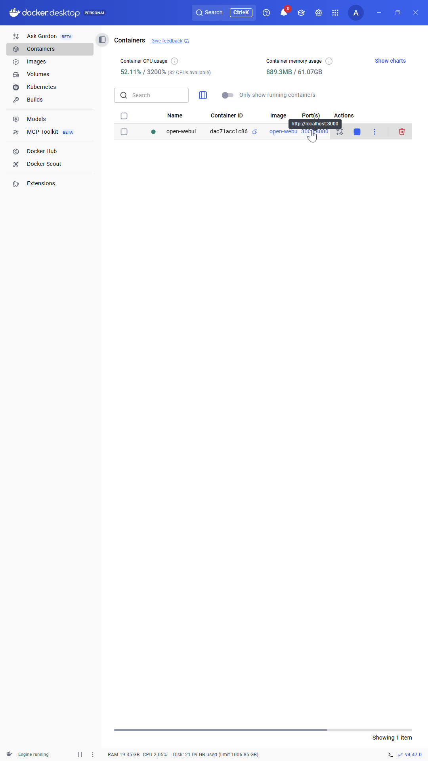
Now create an account and chat whatever you want to the AI model
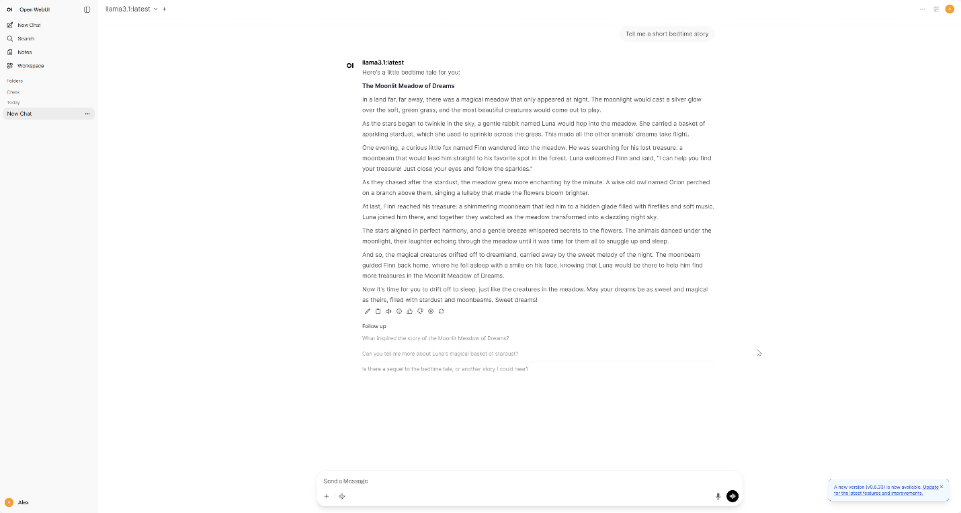

Problems:
The only problem I had during this lab was when I accidentally tried to use a hot-swappable NVMe drive case without an actual drive installed. Because of that, Ubuntu had nowhere to install, and the setup process came to a stop until I purchased a new NVMe drive. Once the new drive arrived, installation went smoothly. This mistake was simple but a good reminder to double-check hardware before starting any system-level configuration.

